Sidel Trade Compliance Application – Help File (Brokers)

- Logging into the website
  - Go to the following URL in your web browser:
    - http://sidel.customspoint.com OR http://207.195.233.151/
    - Enter your User Name & Password in the upper-right area
    - Click on the “Login” button
  - 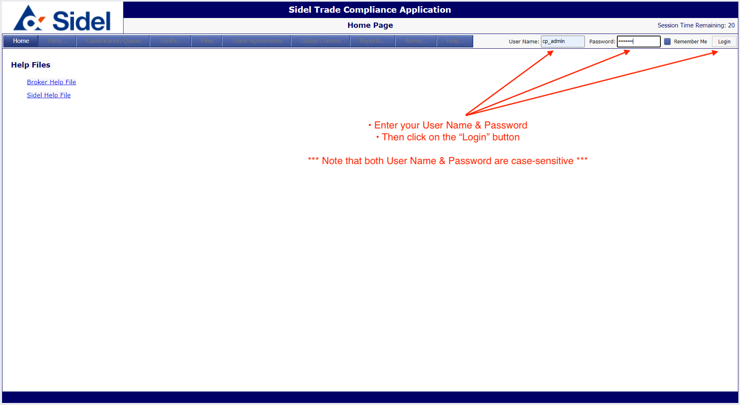
  - 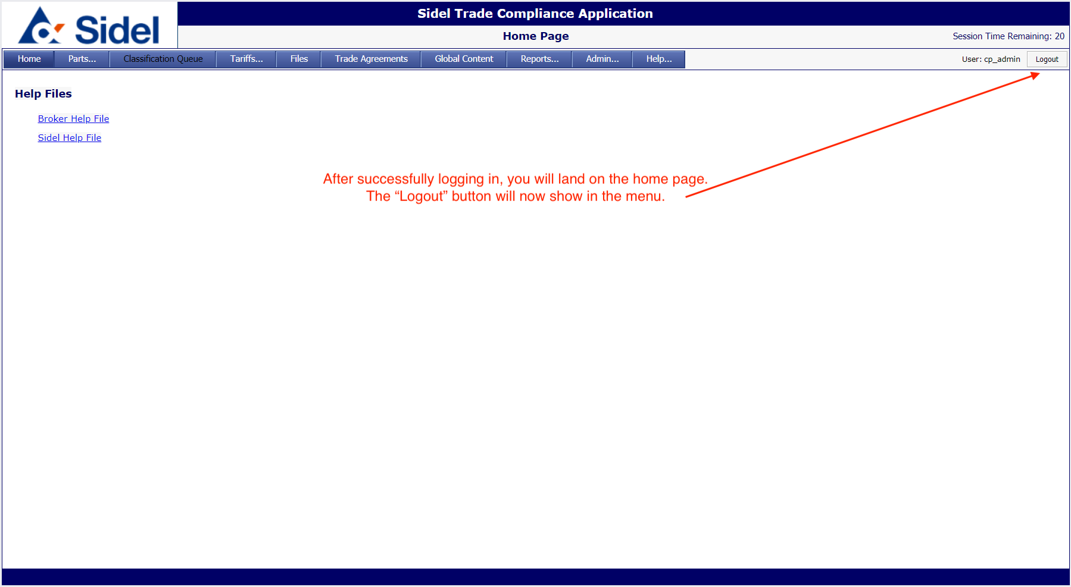
- Accessing the Parts/Products Area
  - Click on the Parts menu and then select “Part List”
  - This will take you to the parts search page
  - 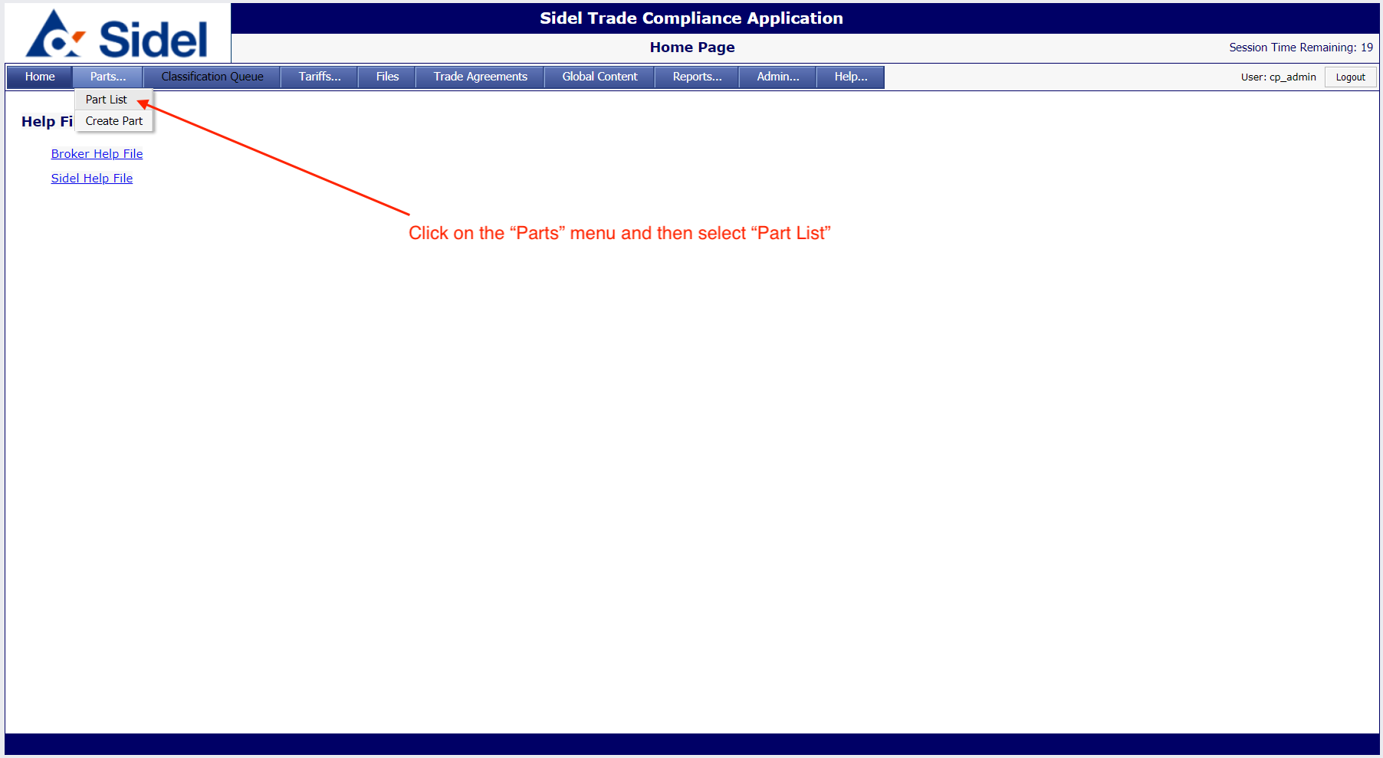
- Searching for parts in the Sidel catalog
  - The Parts List page allows you to search for parts using one or more search parameters
  - 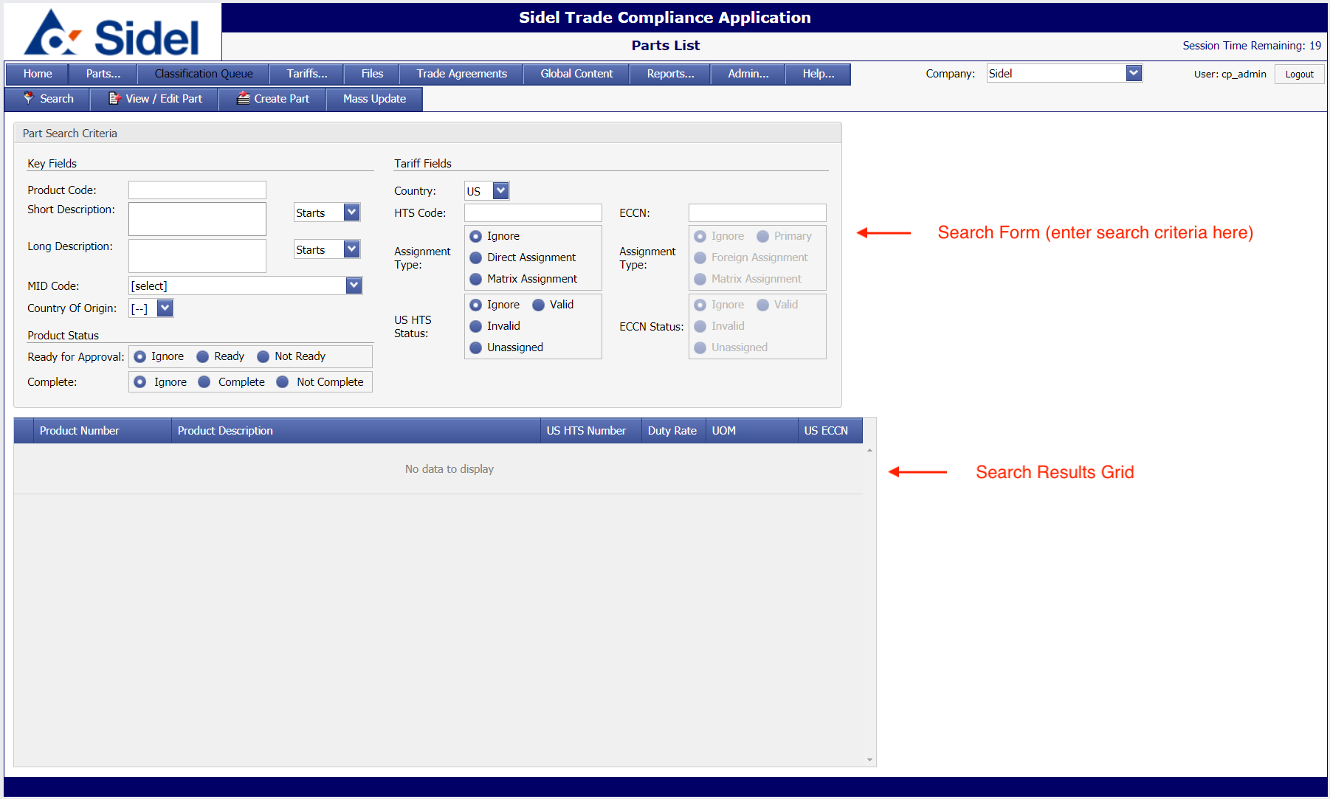
  - Clicking the “Search” button without entering any search parameters will return the entire Sidel parts database
  - 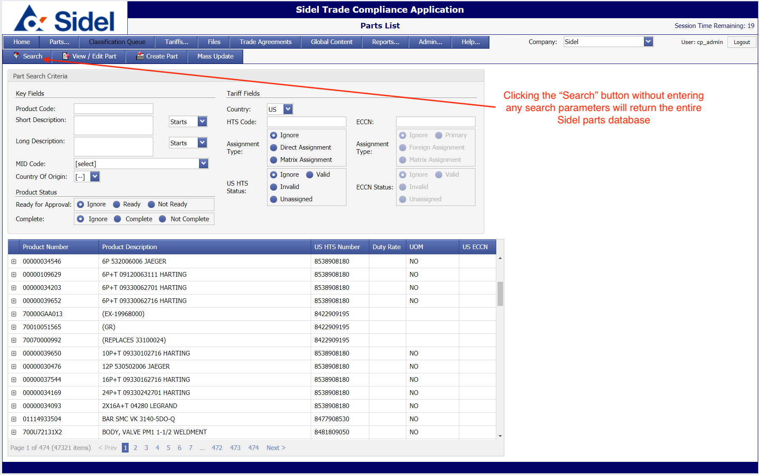
  - To search for a single part, enter the part number and click on the “Search” button.
    - You can enter a partial part number and the application will find all parts starting with the partial number entered.
    - The search results will be shown in the table below.
  - 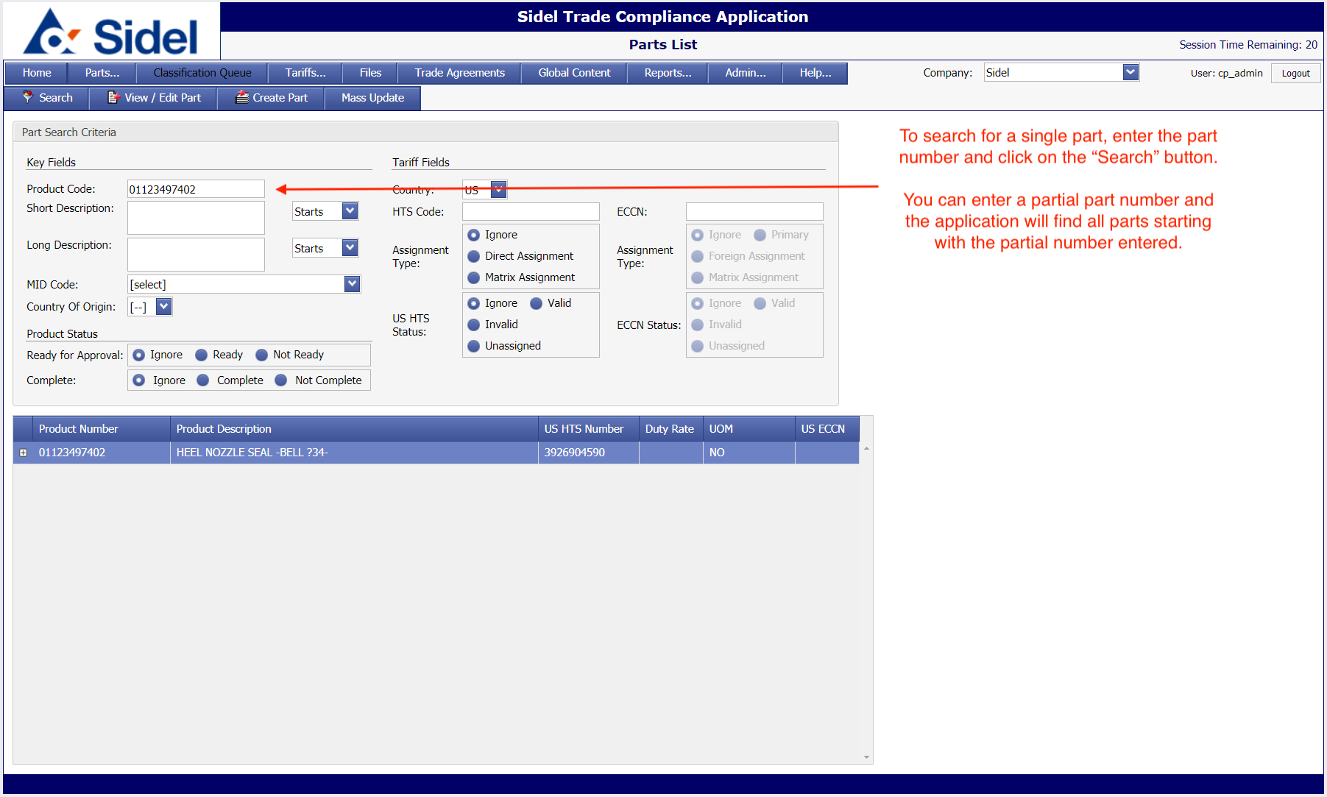
  - To search for parts by keyword, enter the keyword(s) and click the “Search” button.
    - Use the drop-down menu to select how to search:
      - Starts: Will return all parts with a description starting with the keyword(s) entered.
      - Contains: Will return all parts that have a description that contains the keyword(s) entered.
      - Ends: Will return all parts where the description ends with the keyword(s) entered.
  - 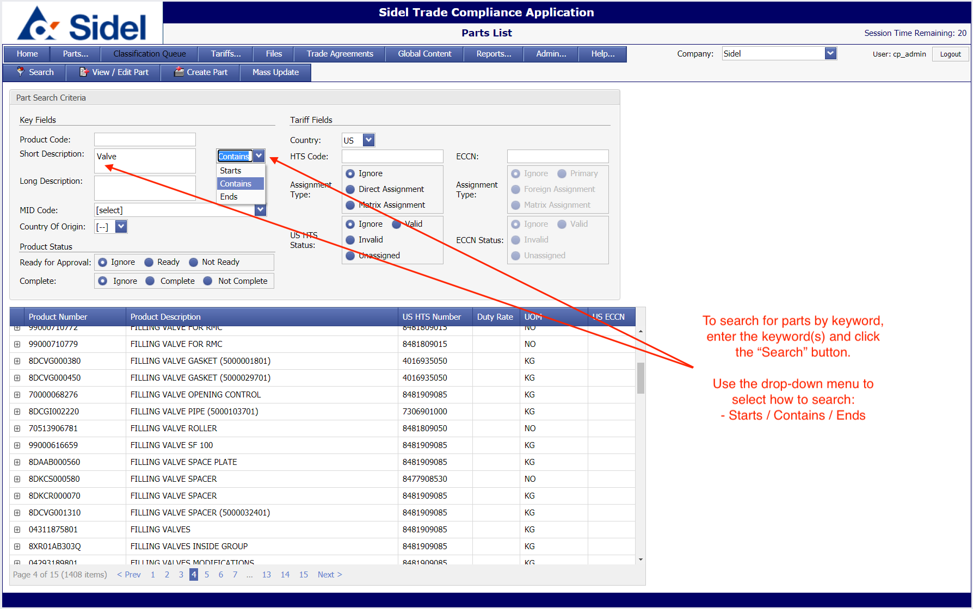
  - To search for parts by US HTS code, enter the HTS code and click the “Search” button.
    - Enter a partial HTS code to find parts at the 6-digit or 8-digit level.
  - 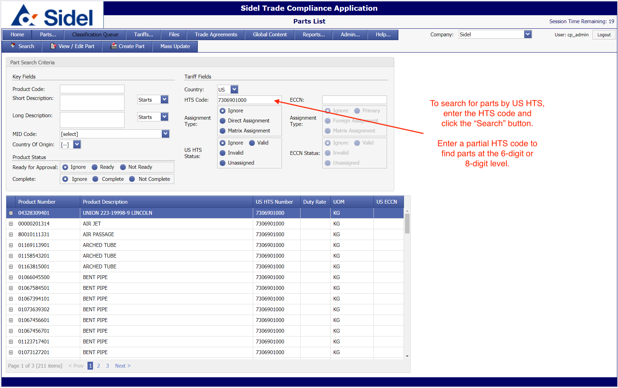
  - To search for parts based on the HTS Status, choose a status and then click the “Search” button.
    - Invalid: Choose this option to find parts that have an HTS code that is no longer valid.
    - 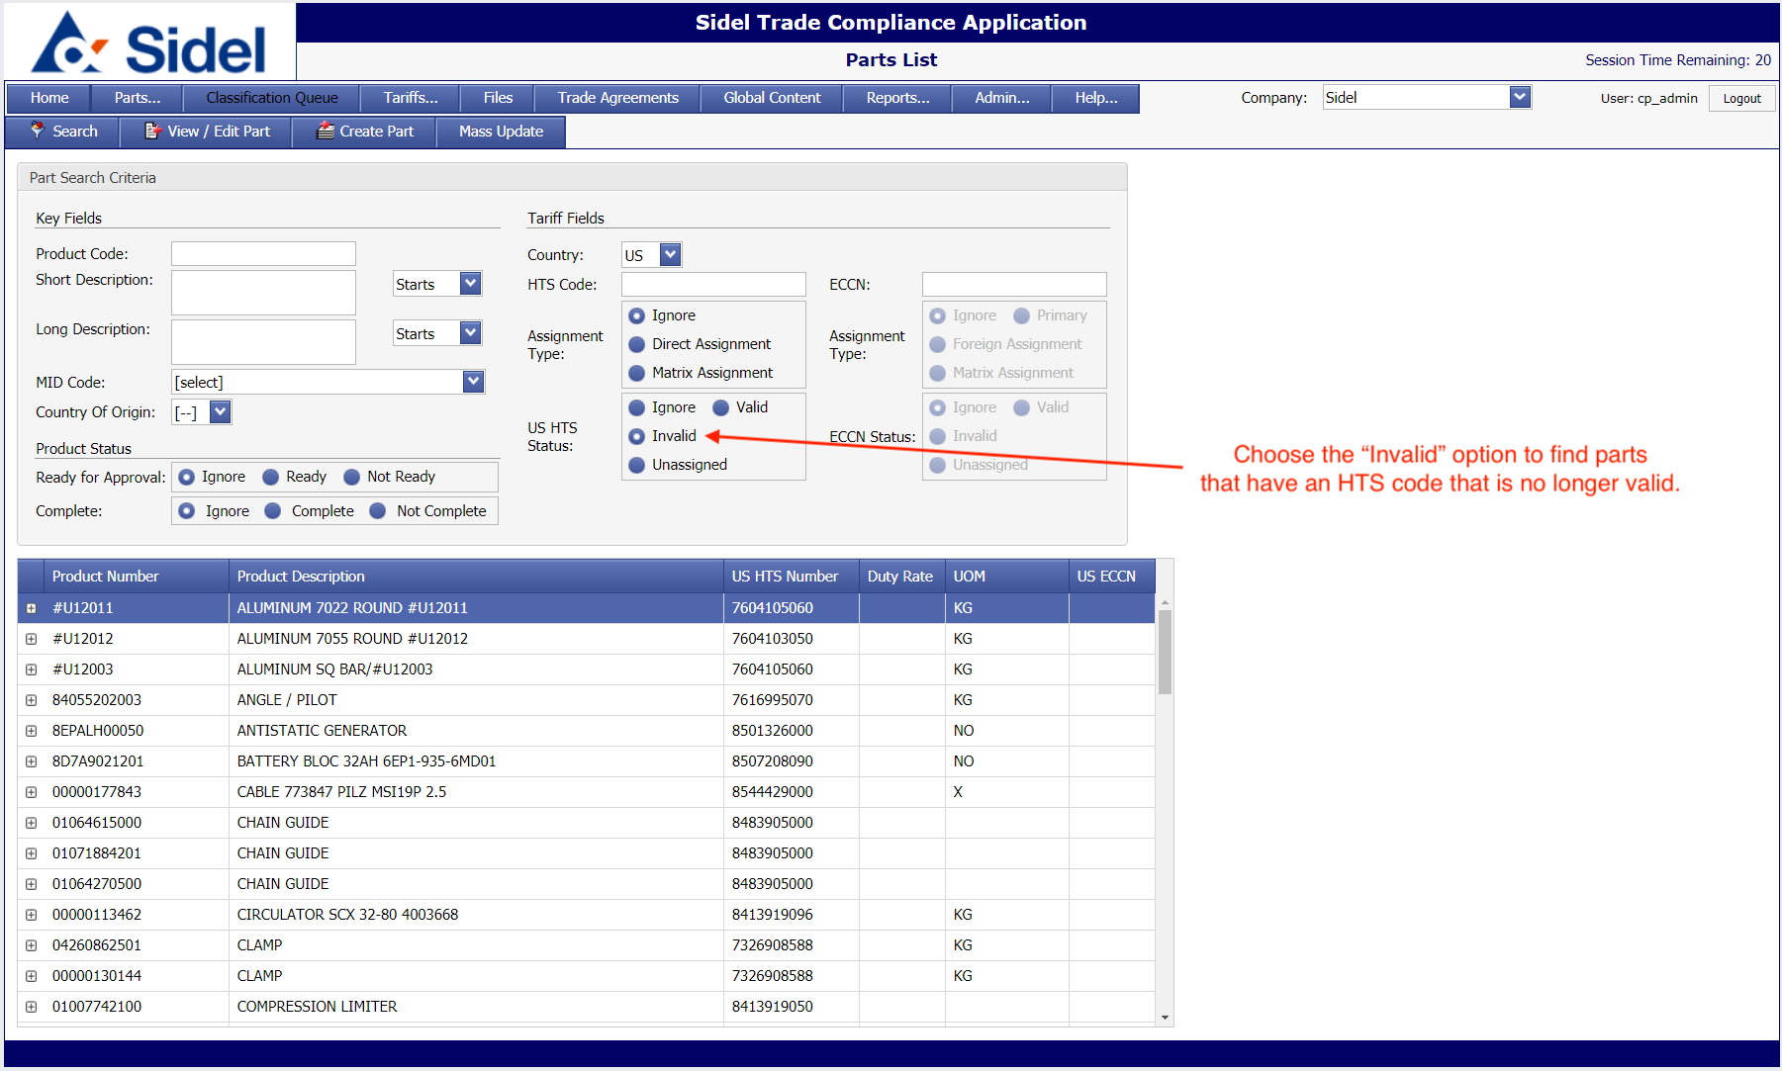
    - Unassigned: Choose this option to find parts that do not yet have an HTS code assignment.
    - 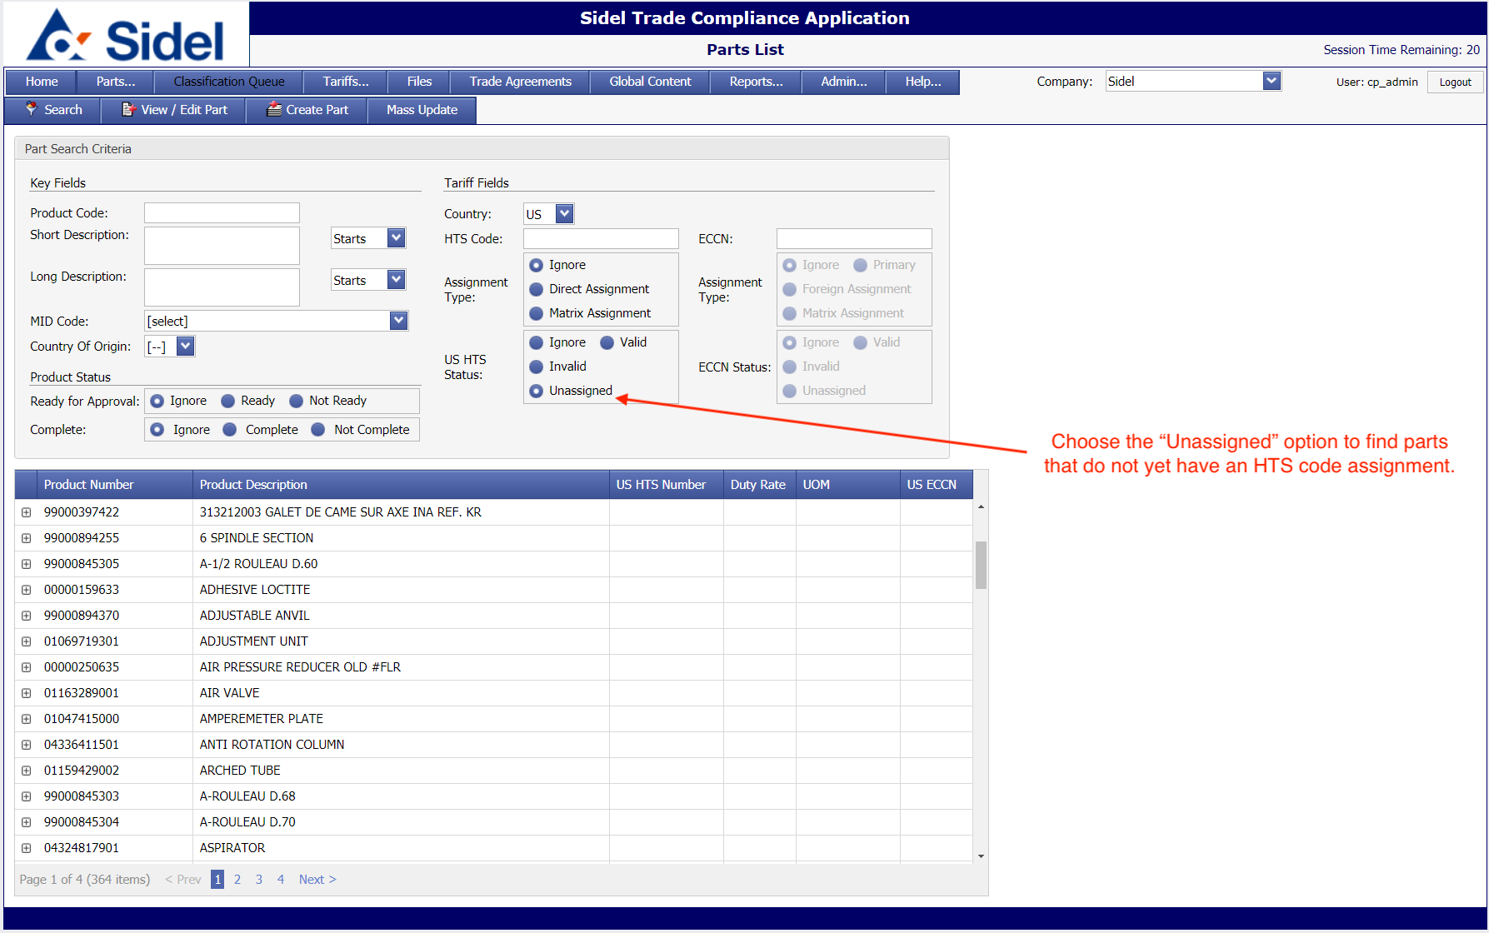
- Part Compare Report
  - The Part Compare Report allows you to upload a list of parts to retrieve product and HTS information.
    - Click on the ‘Part Compare Report’ button to upload a list of parts to retrieve product & HTS information.
    - You can download a copy of the Excel (XLS) template in the pop-up window.
    - Add your list of part numbers to the file and save it locally. Once completed, click the ‘Choose File’ button to locate the upload file you created.
    - Last, click the ‘Get Report’ button to download an Excel file that contains the product & HTS information that you requested.
    - 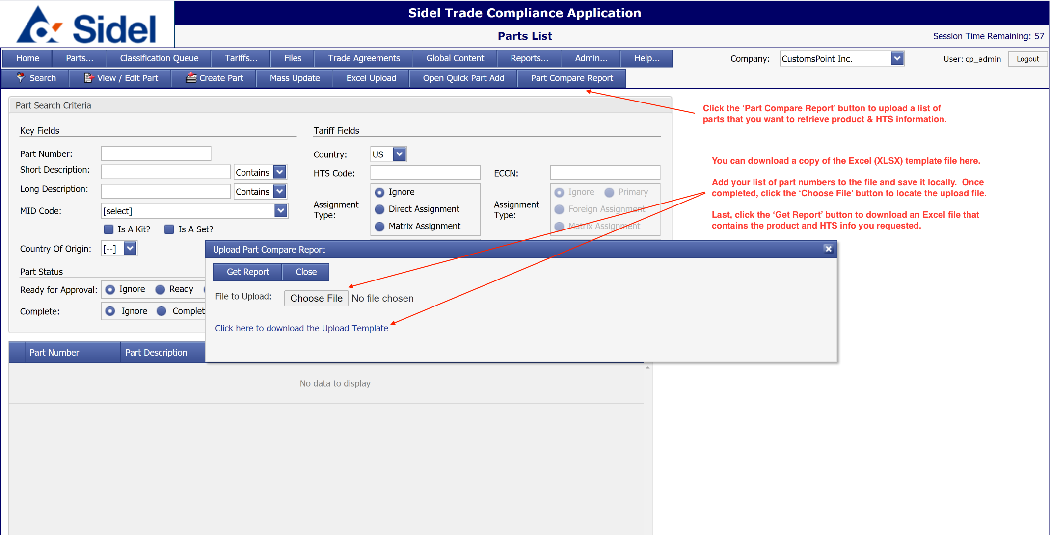
    - 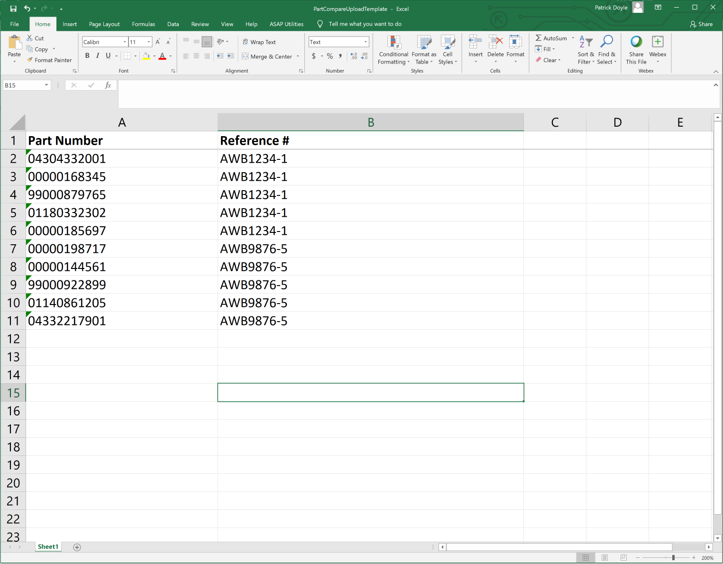
    - 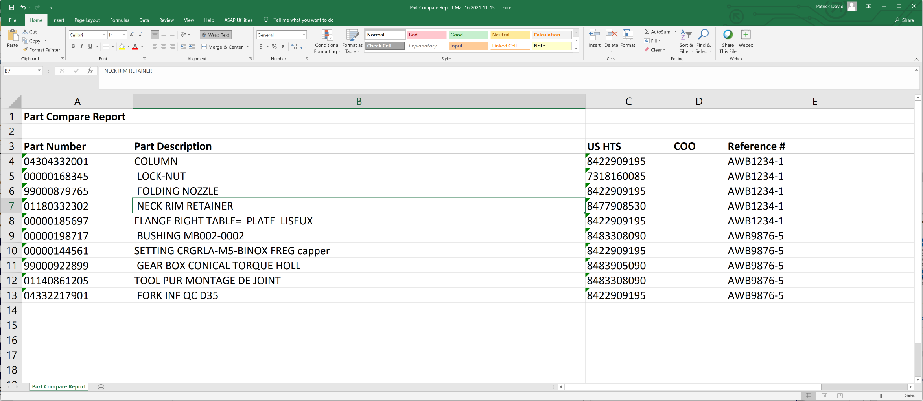
- Search US HTS Data
  - The “Tariff Search” allows users to search for complete or partial US HTS codes.
  - Results are shown in a “tree” view, allowing the user to see codes and descriptions, from chapter level through the complete 10-digit level.
  - Selecting a 10-digit code will show the following:
    - Complete 10-digit description
    - Effective dates
    - Rates and special programs
  - 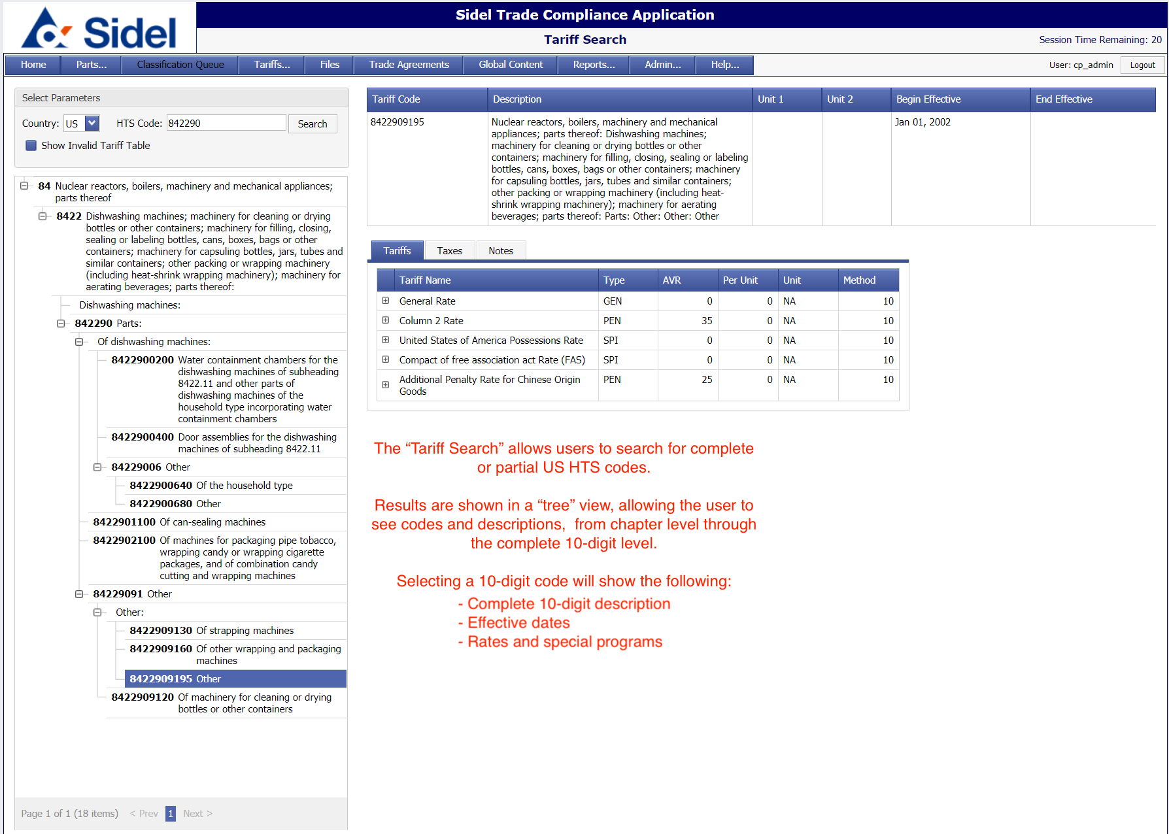
- Support
  - For support issues contact:
    - Patrick Doyle
    - Email: patrickd@customspoint.com
    - Phone: 512.983.0294

